 | Foreclusre reports
1. | FHA Foreclosure Claims
 | Field Name | Location | Field name |  | comments
 | Loan #
 | Name | Ms_borrower_information | Borrower_last
 | Type | Ms_loan_information | Loan_type
 | UPB | Ms_loan_balances | Ytd_prin_paid_amt |  | Loan paidoff
 | UPB | Ms_loan_balances | Prin_bal |  | Loan Not paidoff
 | F/ C Date | Ms_fcl_items_amts_1 | Fcl_item_date
 | Hud Advice on Payment Part A | Ms_flc_items_amts_2 | Fcl_item_recvd_expd |  | 11200 ensure description is part A
 | Payment Amount Part A | Ms_flc_items_amts_2 | Fcl_item_amt |  | 11200 amount look at pic below
 | Debenture Rate | Ms_fcl_fha_info | Fcl_debenture_rate
 |  | 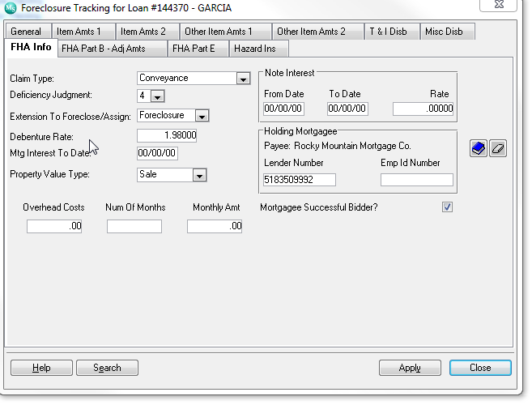
 | Debenture Interest Paid | Ms_loan_misc_fields | Misc_dec_value |  | Debenture  Label A
 | Interest Rate | Ms_loan_information | Int_rate |  | Ir for note
 | Interest of PayOff | Ms_gnma_inv_loan | Gnma_pif_int_due |  | Label B
 |  | 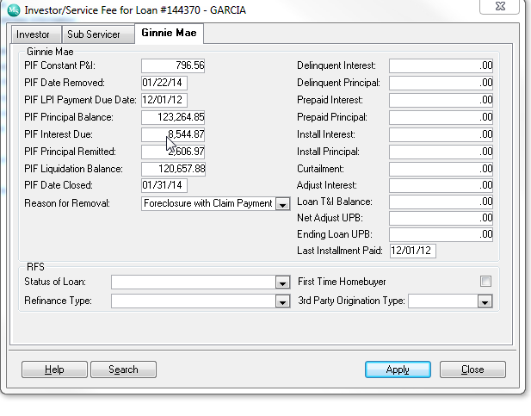
 | Difference on Interest | Calculation difference between label b and label A | Jaime they are highlighted on description

